RESOLUTION NO.__________

RE: CERTIFICATE OF APPROPRIATENESS UNDER THE
PROVISIONS OF THE ACT OF THE PENNSYLVANIA
LEGISLATURE 1961, JUNE 13, P.L. 282 (53
SECTION 8004) AND BETHLEHEM ORDINANCE NO.
3952 AS AMENDED.

WHEREAS, it is proposed to install a fence along the west side of 321 E Third Street.

NOW, THEREFORE, BE IT RESOLVED by the Council of the City of Bethlehem that a Certificate of Appropriateness is hereby granted for the work.

Sponsored by: (s)

(s)

ADOPTED BY COUNCIL THIS DAY OF

(s)
President of Council

ATTEST:

(s)
City Clerk

HISTORIC CONSERVATION COMMISSION

CASE # 569– It is proposed to install a fence along the west side of 321 E Third Street
OWNER/APPLICANT: Charter Arts Foundation / Diane LaBelle

The Commission upon motion by Mr. Evans seconded by Mr. Roeder adopted the proposal that City Council issue a Certificate of Appropriateness for the proposed work described herein:
- The proposal to install a fence along the west side of rear utility area of 321 E Third Street was submitted for review as a part of old business.
- The fence on the west side of the property between 321 and 313 E. Third St. was inadvertently not included in the fence submission that was reviewed by the HCC in June 2015.
- As required by the Zoning Ordinance, the fence will be solid.
- The fence will be a fabricated of a composite material with a matte finish such as Trex Seclusions or equivalent. It will be un-textured and have a solid color through the entire material. The fence will not be vinyl.
- The fence will be 6’ high.
- The proposed motion was unanimously approved.

CU: cu
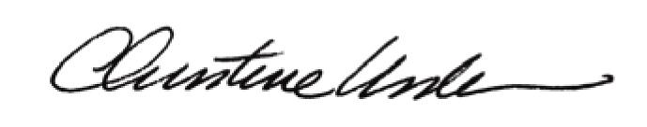

By:

Date of Meeting: October 19, 2015 Title: Historic Officer

